**BIG DATA ANALYSIS WITH IBM CLOUD DATABASES**

**Abstract:**

Big data is a collection of massive and complex data sets and data volume that include the huge quantities of data, data management capabilities, social media analytics and real-time data. Big data analytics is the process of examining large amounts of data.

**Advanced Analysis Techniques:**

**Machine Learning Algorithms:**

Machine learning is a subset of artificial intelligence that focuses on developing algorithms capable of learning from and making predictions or decisions based on data. In the context of annual surface temperature datasets, machine learning techniques are employed to model relationships and patterns within the data. These algorithms can be broadly categorized into the following types:

1. **Supervised Learning:**

In supervised learning, the algorithm is trained on a labelled dataset, meaning it learns to map input data (annual temperature records) to corresponding output labels (e.g., temperature values or trends). Common supervised learning algorithms used for temperature analysis include linear regression, decision trees, random forests, and support vector machines.

1. **Unsupervised Learning:**

Unsupervised learning is used to discover patterns and structures in the data without labelled output. Techniques like clustering and dimensionality reduction can be applied to identify temperature clusters, anomalies, or reduce the dataset's complexity.

1. **Time Series Forecasting**:

Temperature data is inherently sequential, making time series forecasting an essential machine learning task. Algorithms such as ARIMA (Autoregressive Integrated Moving Average), Exponential Smoothing, and more advanced methods like Long Short-Term Memory (LSTM) neural networks are utilized to predict future temperature values based on historical data.

1. **Deep Learning:**

Deep learning, a subset of machine learning, involves neural networks with many layers. Deep learning techniques, including convolutional neural networks (CNNs) and recurrent neural networks (RNNs), are applied to capture complex patterns in spatiotemporal temperature data or for feature extraction.

**Time Series Analysis:**

Time series analysis is a specialized field of statistics and data analysis that focuses on understanding, modeling, and forecasting data that evolves over time. In the case of annual surface temperature datasets, time series analysis entails the following:

**1. Exploratory Data Analysis (EDA):**

EDA involves visualizing and summarizing the data to uncover trends, seasonality, and potential outliers in temperature records. EDA helps in identifying patterns and understanding the underlying structure of the time series.

**2. Decomposition**:

Time series data can be decomposed into three main components: trend, seasonality, and residuals. The trend represents the long-term behaviour, seasonality accounts for recurring patterns, and residuals capture irregular variations. Decomposition is essential for separating and analysing these components.

**3. Forecasting:**

Time series forecasting aims to predict future temperature values based on historical observations. A wide range of models can be employed, from simple methods like exponential smoothing and ARIMA to more complex ones like state-space models and machine learning algorithms.

**4. Anomaly Detection:**

Identifying anomalies or outliers in temperature data is critical for monitoring and addressing unusual or extreme temperature events. Time series analysis can help in flagging unusual temperature spikes or drops.

In summary, machine learning algorithms and time series analysis techniques are indispensable tools for comprehensively analysing annual surface temperature datasets. They allow us to model temperature patterns, make predictions, and gain insights that are valuable for various applications, including climate science, agriculture, and energy management. These techniques help us extract meaningful information from the wealth of temporal temperature data available.

Applying more complex analysis techniques to a dataset of annual surface temperatures typically involves time series analysis and predictive modeling.

**Install necessary python package files**

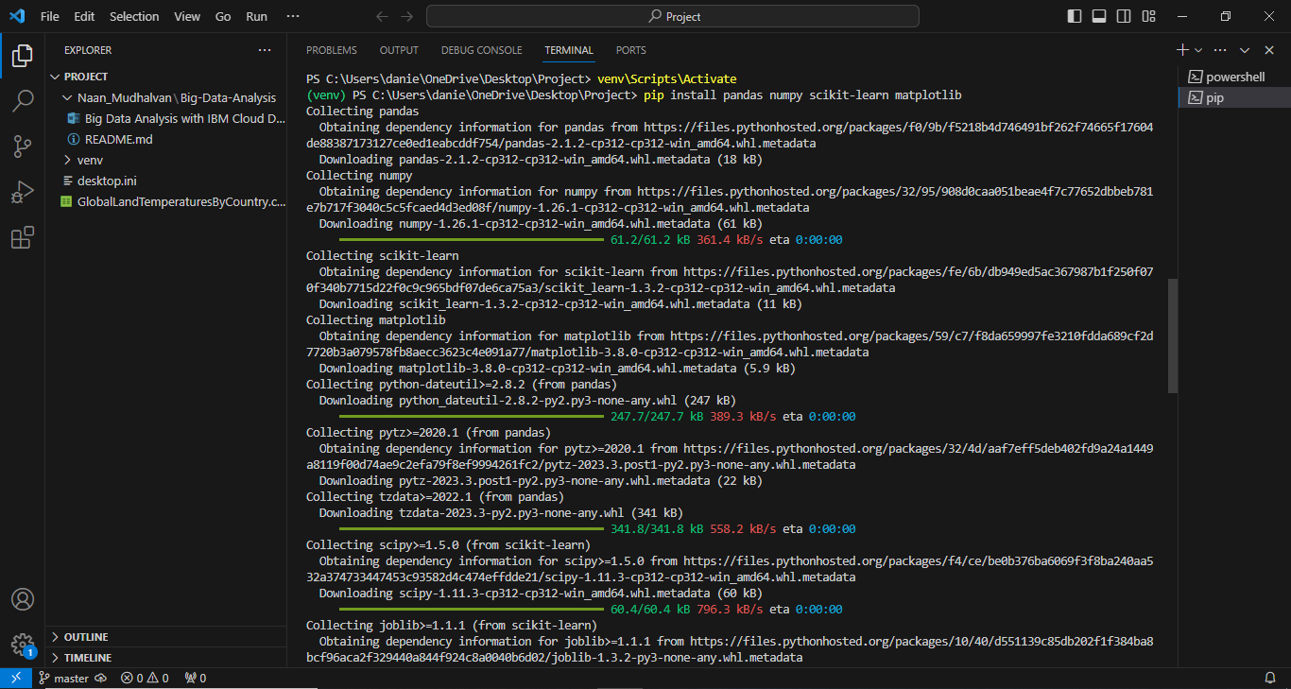

**Step 1:** **Data Preparation**

import pandas as pd

import numpy as np

import matplotlib.pyplot as plt

Import seaborn as sns

#Load the GlobalLandTemparatureyCountry dataset

data=pd.read_csv(‘GlobalLandTemparatureyCountry.csv’)

#Explore the data

print(data.head())

Print(data.info())

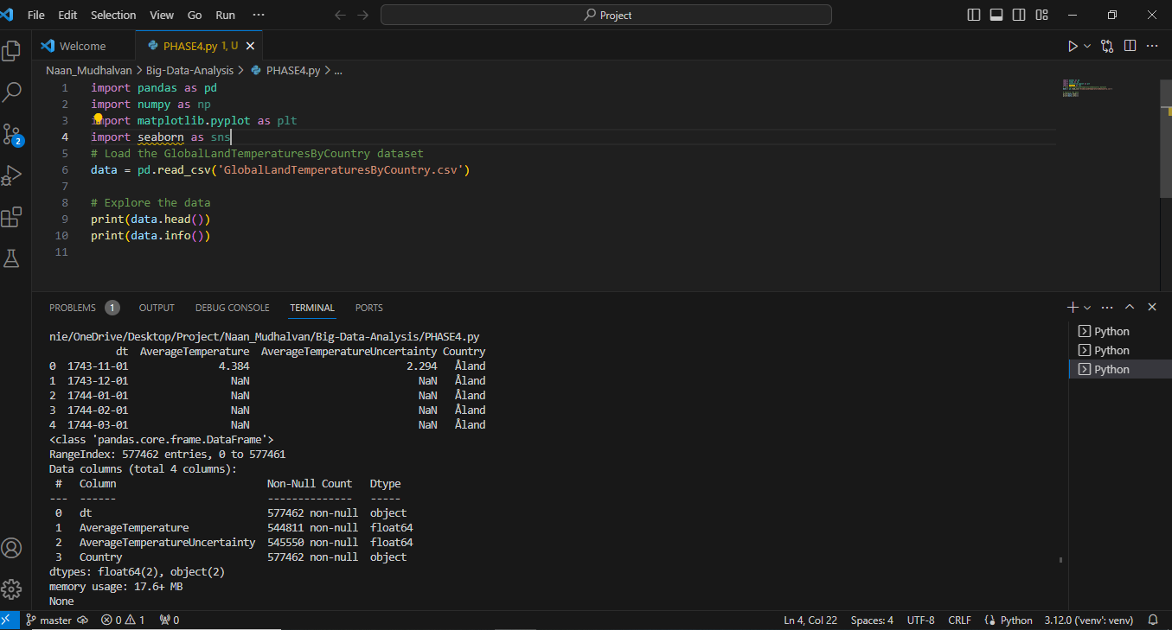

**Step 2: Time Series Analysis**

Time series analysis can help identify trends, seasonality, and perform forecasting. Below is a simplified example of performing a decomposition and visualization of the data.

import statsmodels.api as sm

import matplotlib.pyplot as plt

#Load the GlobalLandTemparatureyCountry dataset

data=pd.read_csv(‘GlobalLandTemparatureyCountry.csv’)

# Decompose the time series data

decomposition = sm.tsa.seasonal_decompose(data['Temperature'], model='additive')

trend = decomposition.trend

seasonal = decomposition.seasonal

residual = decomposition.resid

# Plot the decomposed components

plt.figure(figsize=(12, 6))

plt.subplot(411)

plt.plot(data['Temperature'], label='Original')

plt.legend(loc='upper left')

plt.subplot(412)

plt.plot(trend, label='Trend')

plt.legend(loc='upper left')

plt.subplot(413)

plt.plot(seasonal, label='Seasonal')

plt.legend(loc='upper left')

plt.subplot(414)

plt.plot(residual, label='Residual')

plt.legend(loc='upper left')

plt.tight_layout()

plt.show()

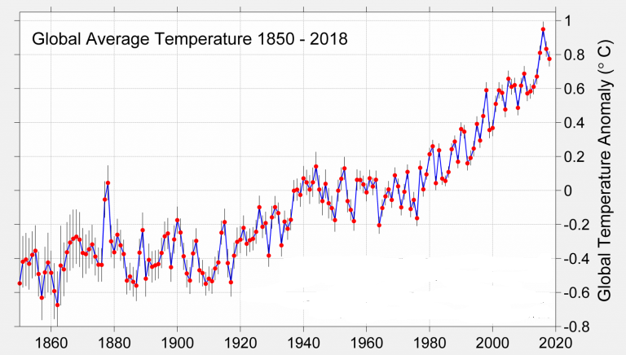

**Step 3: Machine Learning (Regression)**

You can also use machine learning for predictive modeling. Let's use a regression model to predict future temperatures based on historical data.

from sklearn.model_selection import train_test_split

from sklearn.linear_model import LinearRegression

from sklearn.metrics import mean_squared_error, r2_score

# Prepare data for machine learning

data['Year'] = data.index.year

X = data[['Year']]

y = data['Temperature']

# Split data into training and testing sets

X_train, X_test, y_train, y_test = train_test_split(X, y, test_size=0.2, random_state=42)

# Train a linear regression model

model = LinearRegression()

model.fit(X_train, y_train)

# Make predictions

y_pred = model.predict(X_test)

# Evaluate the model

mse = mean_squared_error(y_test, y_pred)

r2 = r2_score(y_test, y_pred)

print(f'Mean Squared Error: {mse}')

print(f'R-squared: {r2}')

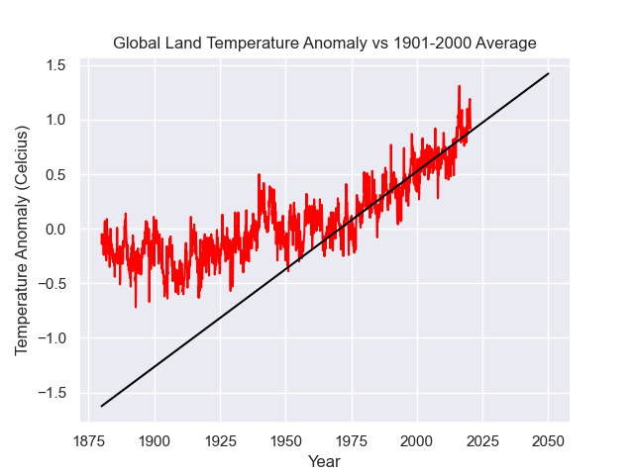

This code provides a simplified example of time series analysis and predictive modeling. In practice, you would explore more sophisticated time series models, feature engineering, and hyperparameter tuning for machine learning models to achieve better results. Additionally, you might want to consider advanced techniques like ARIMA, LSTM, or Prophet for time series analysis.

**Visualization:**

Visualizations are essential for showcasing analysis results and understanding data. Matplotlib and Plotly are popular Python libraries for creating various types of graphs and charts

**Using Matplotlib:**

Matplotlib is a powerful Python library for creating static visualizations. You can create various types of plots, including line plots, bar charts, and histograms.

import matplotlib.pyplot as plt

# With 'Year' and 'Temperature' columns

# Line plot of annual temperature trends

plt.figure(figsize=(12, 6))

plt.plot(df['Year'], df['Temperature'], marker='o', linestyle='-', color='b')

plt.title('Annual Surface Temperature Over Time')

plt.xlabel('Year')

plt.ylabel('Temperature (°C)')

plt.grid(True)

plt.show()

# Histogram of temperature distribution

plt.figure(figsize=(10, 6))

plt.hist(df['Temperature'], bins=20, color='g', alpha=0.7)

plt.title('Temperature Distribution')

plt.xlabel('Temperature (°C)')

plt.ylabel('Frequency')

plt.grid(True)

plt.show()

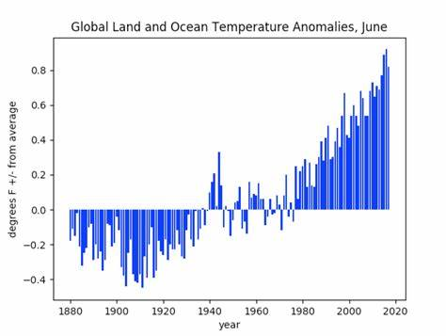

**Using Plotly:**

Plotly is an interactive plotting library that allows for creating interactive and dynamic visualizations. It is particularly useful when you want to explore data and analyse it interactively.

import plotly.express as px

# Create a line plot using Plotly

fig = px.line(df, x='Year', y='Temperature', title='Annual Surface Temperature Over Time')

fig.update_xaxes(title='Year')

fig.update_yaxes(title='Temperature (°C)')

fig.show()

# Create a histogram using Plotly

fig = px.histogram(df, x='Temperature', title='Temperature Distribution')

fig.update_xaxes(title='Temperature (°C)')

fig.update_yaxes(title='Frequency')

fig.show()

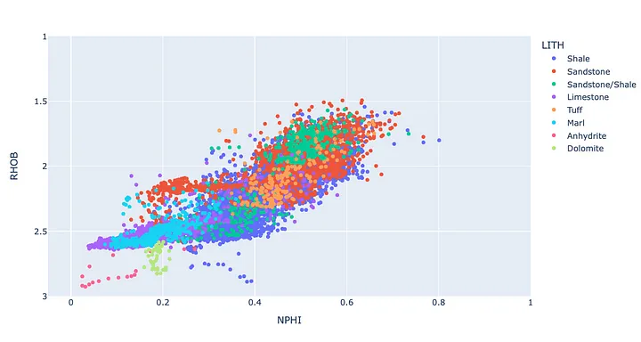

The provided code snippets demonstrate creating a line plot showing annual temperature trends over time and a histogram displaying the distribution of temperatures.

**Conclusion:**

In conclusion, advanced analysis techniques such as machine learning and time series analysis algorithms play a transformative role in our understanding of annual surface temperature datasets. Machine learning models enable the identification of intricate patterns, correlations, and predictive insights, allowing us to forecast climate changes, extreme events, and their potential impacts. Time series analysis aids in unraveling long-term temperature trends and anomalies, providing valuable historical context for climate assessments. By harnessing these techniques, we can make informed decisions, adapt to climate challenges, and develop proactive strategies to mitigate the effects of global temperature variations. These cutting-edge approaches are essential tools in addressing the complex and urgent issues posed by climate change.